Visual Designs

Homepage
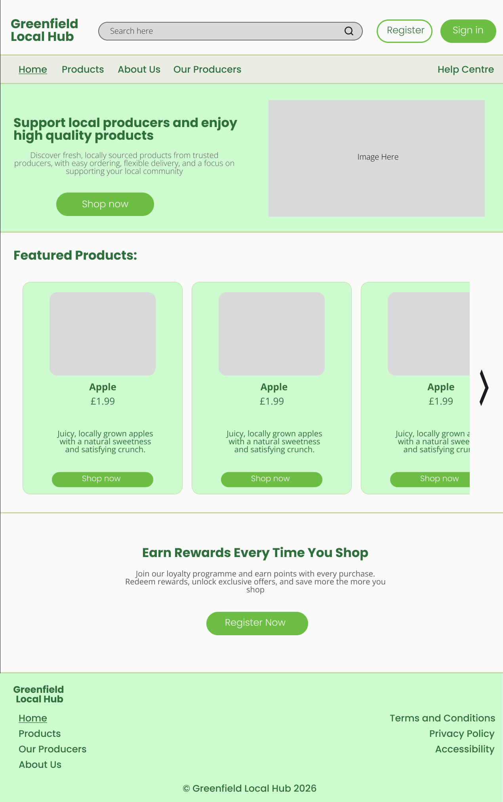

Navigation Bar (Navbar)
The navigation bar is positioned at the top of the page as this follows standard web design conventions. Placing the navigation at the top help users find key areas or products of the website easily and quickly. This helps the users to navigate efficiently in the website overall improving the websites usability. The nav bar uses a background colour of E9EDE4 which creates a soft, clean appearance that aligns with the theme of the company. The navigation links use Poppins, Medium, font size 24 and colour 2F6F3E to ensure visibility and consistency with the typography. Wherever the users active page is, such as “Home” is underlined to provide a clear visual indicator of the user’s current location within the website which improves the user experience. The “Help Centre” navigational link is positioned on the far right of the navbar to avoid clutter on the nav bar improving the user experience.

Navbar Header
Above the nav bar, a header section is used to display key elements. The company logo is positioned on the left following common web design patterns allowing the users to recognise the brand and return to the homepage if needed. A search bar is positioned at the centre to help the users find products quickly. The search bar uses a background colour of D9D9D9 with a stroke colour of 6B6B6B making the search bar clearly visible while maintaining a neutral appearance. The placeholder text “Search Here” uses Open sans, Light, font size 20 and colour 2E2E2E to ensure its readability. On the right side of the header a register and login button is included. The register button uses a background colour of FAFAF8 with a border colour of 6DBE45 making it stand out subtly without overwhelming the design. The button text uses Poppins, Light, size 24 and colour 2F6F3E. Meanwhile the sign in button uses a background colour of 6DBE45 and the text is the same as the register button except for the colour which is FAFAF8 for the sign in button. This helps clearly separate the two buttons making it easier for users to know which is which. Both buttons help reinforce the brands identity.

Divider line
A thin divider line with a colour of C5D8A4 with a weight of 3 is used to separate sections with one another. This helps structure the layouts clearly and improve visual hierarchy without distracting the user.

Hero Section
The hero section of the homepage uses a background colour of CEFAD0 which helps reinforce the theme of the company. The soft green colour creates a welcoming first impression while maintaining consistency with the brand identity. The layout follows common web conventions where text is aligned to the left and a supporting image is placed on the right. This improves readability and ensures that the users know what the website is about. The button is positioned below the body text creating a clear visual flow guiding the user.

Headings
The headings use Poppins, Bold, font size 32 and colour 2F6F3E. This font was chosen because it is modern, clean and matches well with the theme of the company making it suitable to draw the users attention. The green colour reinforces the brand identity and matches the theme of the company. Using consistent heading styles throughout the website ensures a clear visual hierarchy helping users quickly identify important sections which improves the overall user experience.

Body Text
The body text uses Open Sans, light, font size 20 and colour 595959. Open Sans was selected for its high readability. The slightly muted grey colour reduces visual strain compared to pure black while maintaining sufficient contrast against the background colour.

Buttons
Buttons use a background colour of 6DBE45 with text styled in Poppins, Light, font size 24 and colour FAFAF8. The green button colour helps in making interactive elements clearly visible while maintaining the theme of the website. The light colour text provides strong contrast against the buttons background colour making it clear and visible. The buttons styling remains consistent within the website which help improves the usability and navigation of the website overall improving the user experience.

Featured Products Section
The featured products section is designed using a card-based layout to clearly present product information is a structured and visually appealing way. Each product is displayed within an individual card. The card uses a CEFAD0 background colour and C5D8A4 stroke. Inside the card there is the products image, name, price, a short description of the product and a button that says shop now. The cards are arranged in a horizontal carousel layout. This design encourages user interaction by using a navigational arrow the users can click to see more products overall improving the user experience.
The product name uses Open Sans, Bold, font size 24, colour 2F6F3E. This styling makes sures that the product name stands out clearly within the card making it easily recognisable. The use of bold weight in the typography establishes visual hierarchy while the green font colour maintains consistency with the overall theme of the website.
The price and short description use Open Sans, Regular and colour 2F6F3E the only difference between the two is the font size which is font size 24 for the price and 20 for the short description. This displays the product information in a clear and readable format. The slightly smaller font size from the short description helps establish a hierarchy within the cards. The consistent use of the colour green for the font colour help maintains the overall theme for the website. For the button I used the same design as the other buttons I only changed the font size which is now 20. Using the same helps make the website more consistent and easier to navigate.

Footer
The footer is positioned at the bottom of the page following common conventions providing users a secondary navigation and important information. The company logo is placed on the top left to reinforce brand identity. At the bottom in the footer a copyright text is included to establish professionalism and ownership of the website which is also industry standard and common convention with business websites. On the right side of the footer there are footer link for terms and conditions, privacy and accessibility setting. These are positioned in the right side of the footer to have a properly organised footer links in the footer which improves the user experience. All navigational links use Poppins, Medium, font size 24 and colour 2F6f3E maintaining consistency with the design.

Login
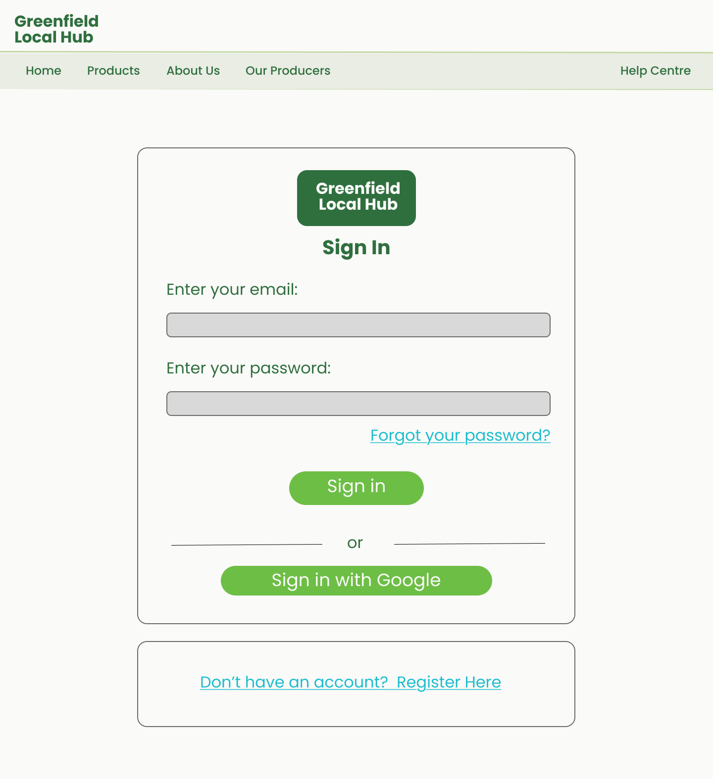

Register
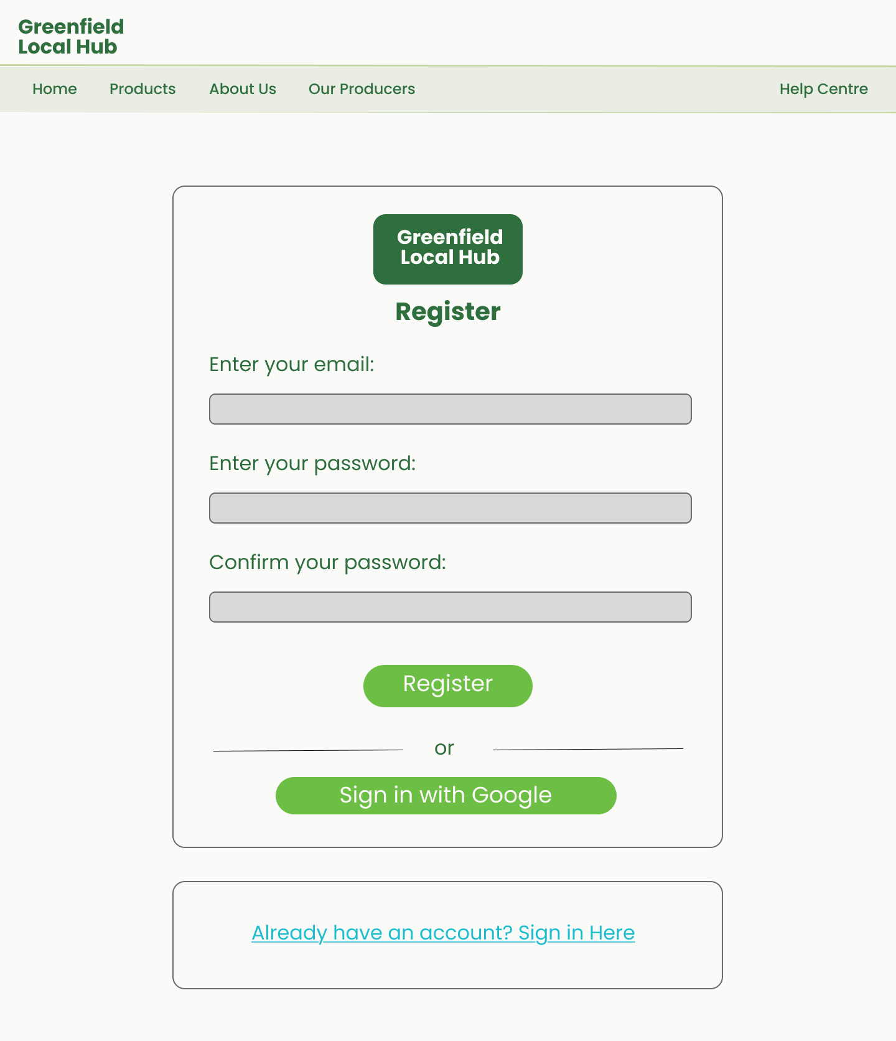

Products
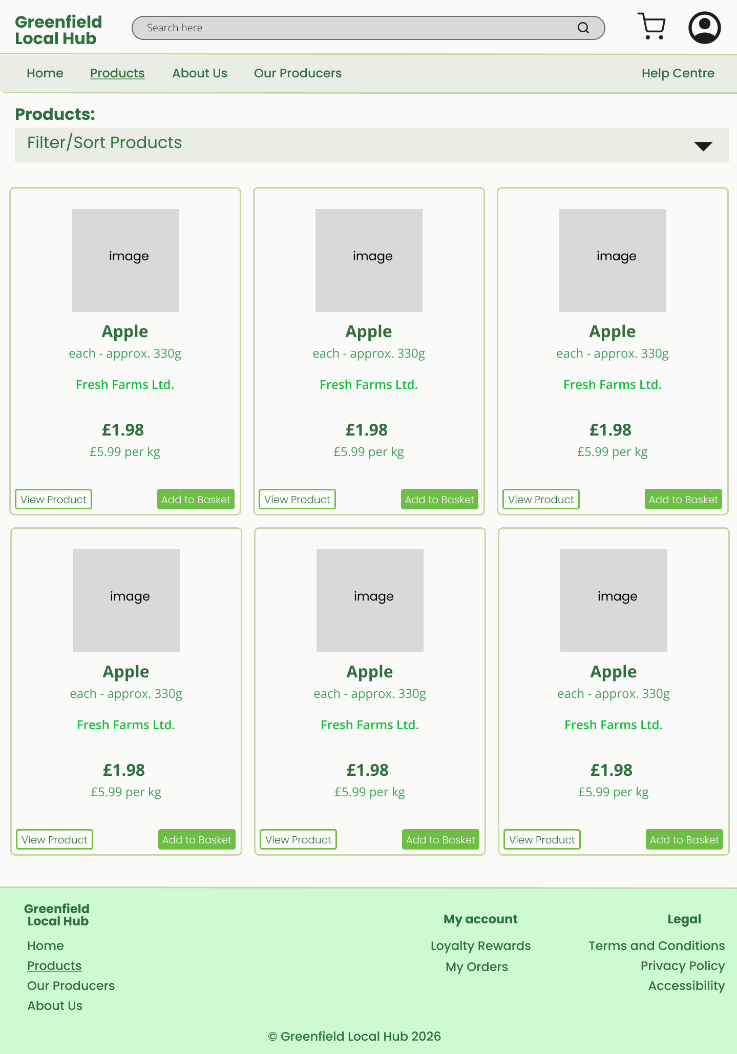

Producers
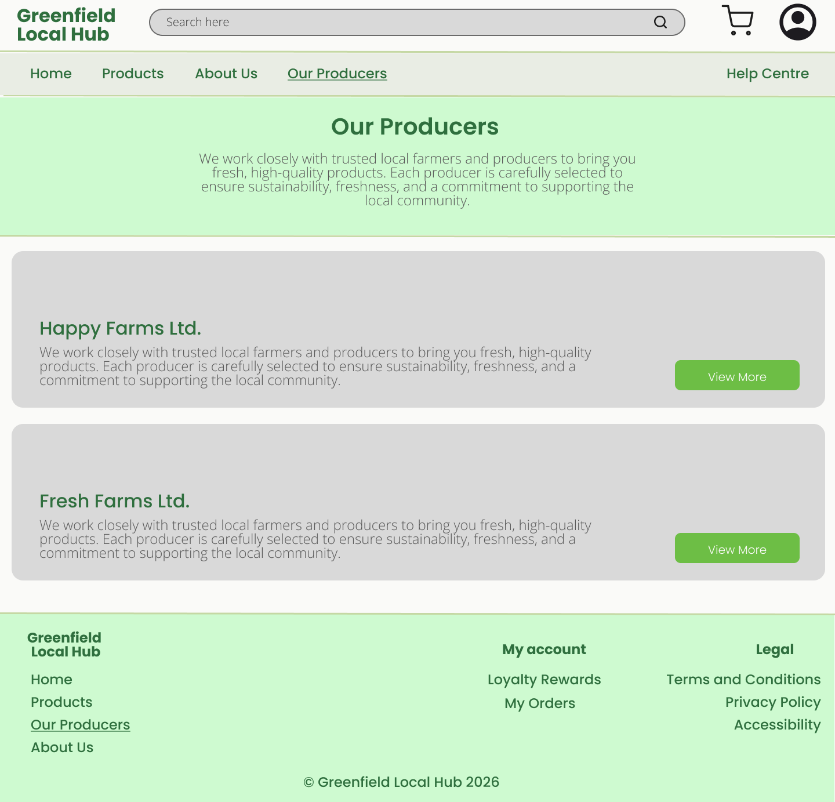

Producer Dashboard
